8-Day Best of Uganda Gorilla and Chimp Trekking Safari

With complimentary Wi-Fi in our vehicle, this safari is tailored to provide you with an immersive experience in three of Uganda's stunning national parks. You'll have the opportunity to observe a variety of wildlife, including chimpanzees, zebras, and antelope herds in Lake Mburo and mountain gorillas in Bwindi. The safari also includes a chance to see the tree-climbing lions of Queen Elizabeth National Park's Ishasha Sector, with a day in between to relax by Lake Bunyonyi.

Route

Uganda
Start | Entebbe (Day 1)
Day 1-2 | Murchison Falls NP
Day 3 | Kibale NP (Chimps)
Day 4-5 | Queen Elizabeth NP
Day 6 | Bwindi Impenetrable NP (Gorillas)
Day 7 | Lake Bunyonyi
End | Entebbe (City) (Day 8)

Tour Features

Mid-range tour
This mid-range tour uses lodges and resorts.

Private tour
This tour will be organized exclusively for you and won't be shared with others.

Can start any day
If availability permits, this tour can start on any day.

Can be customized
You can request minor changes to the accommodations and destinations of this tour.

Not for solo travelers
Solo travelers cannot book this private tour.
16

Minimum age of 16 years
The minimum age for this tour is 16 years.

Activities & Transportation

Activities: game drives, gorilla trekking, chimpanzee trekking, nature hikes/walks & boat trip

Game drives: pop-up roof 4x4 vehicle & pop-up roof minivan

Getting around: pop-up roof 4x4 vehicle & pop-up roof minivan

A transfer from and back to the airport is included

Accommodation & Meals
- Additional accommodation before and at the end of the tour can be arranged for an extra cost
- Day
Accommodation
Meals
- 1-2
Pakuba Safari LodgeMid-range lodge inside Murchison Falls NP

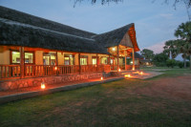

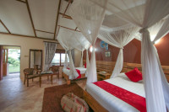

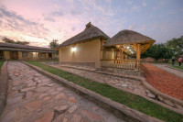

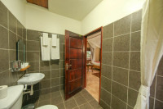+4Photos

Day 1: Lunch & Dinner Included
Day 2: All Meals Included
- 3
Chimpanzee Forest LodgeMid-range guest house just outside Kibale NP (Chimps)

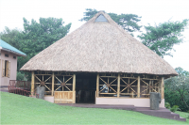

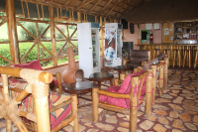

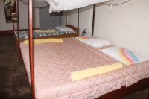

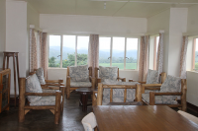

All Meals Included
- 4-5
Lake Munyanyange Caves LodgeMid-range lodge just outside Queen Elizabeth NP

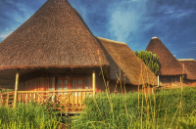

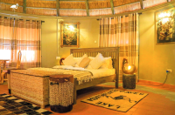



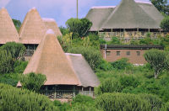+5Photos

All Meals Included
- 6
Rushaga Gorilla LodgeMid-range lodge just outside Rushaga (Bwindi Impenetrable NP)

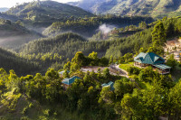

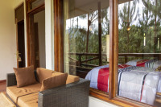

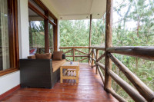

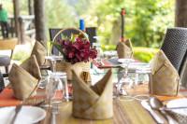+40Photos

All Meals Included
- 7
Lake Bunyonyi Eco ResortMid-range resort at Lake Bunyonyi

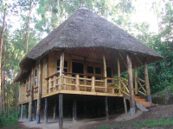

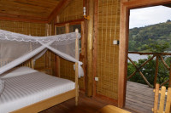

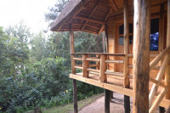

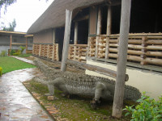

All Meals Included
- 8
End of tour
(No accommodation)
Breakfast & Lunch Included

Arrival (See Getting There for more details)
- You'll be collected from the airport.
- Accommodation before the tour starts can be arranged for an extra cost.
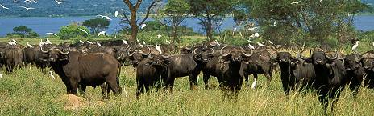

Day 1

Murchison Falls National Park
After arriving at the airport, you will transfer to Murchison Falls National Park. This park is renowned for its roaring rapids and expansive plains, offering excellent opportunities to spot lions, giraffes, hartebeests, buffalos, and elephants. You'll also be captivated by the large populations of hippos and Nile crocodiles. Bird enthusiasts will be thrilled by the park's 450 bird species, including the elusive shoebill stork, dwarf kingfisher, white-thighed hornbill, and the goliath heron. En route to the park, you'll stop at Ziwa Rhino Sanctuary for rhino tracking, followed by a late lunch at Kabalega Dinners Restaurant. Upon arrival at Murchison Falls National Park, you'll first visit the top of the falls to witness one of the world's most powerful waterfalls before heading to your lodge.
Main Destination:
Murchison Falls National Park
Best Time To VisitDecember to February (Easier to spot animals)
High SeasonJune to September (Peak time for Uganda)
Best WeatherJune and July (Less rain and lower temperatures)

Wildlife in Murchison Falls NP
ChimpanzeeOccasional

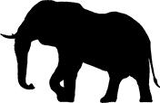
ElephantCommon


GiraffeCommon


LionCommon


BuffaloCommon


HippoAbundant


LeopardOccasional


White RhinoNone


Black RhinoNone


CheetahNone


ZebraNone


WildebeestNone


Wild DogNone
Accommodation:
Pakuba Safari Lodge
- Mid-range lodge located inside Murchison Falls NP







+4Photos

Meals & Drinks:
- Lunch & dinner (Breakfast not included)
- Drinking water (Other drinks not included)
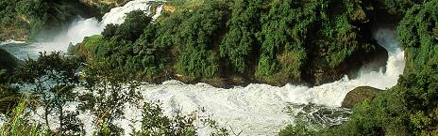

Day 2

Murchison Falls National Park
After breakfast you’ll embark on a game drive in the northern area of the park, where you'll search for some of the “Big Five” (buffaloes, lions, elephants, and possibly leopards). Keep an eye out for other wildlife such as Rothschild giraffes, bushbucks, warthogs, waterbucks, and a variety of antelopes. Return to your accommodation for a delicious lunch and a brief rest.
In the afternoon, you’ll head out on a three-hour boat trip to the base of the falls, which is considered a highlight of any safari here. This cruise offers a close-up view of the aquatic wildlife, including huge hippo pods, crocodiles, and numerous aquatic birds along the north bank as you make your way to the mighty waterfalls. Don't forget your camera, as you'll have plenty of opportunities to take pictures.
After the boat cruise, you’ll enjoy a leisurely game drive back to the lodge.
Main Destination:
Murchison Falls National Park
Accommodation:
Pakuba Safari Lodge
- Mid-range lodge located inside Murchison Falls NP
Meals & Drinks:
- All meals included
- Drinking water (Other drinks not included)
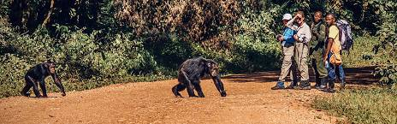

Day 3

Murchison Falls National Park - Kibale National Park
After breakfast, you'll depart early for Kibale Forest National Park. Along the way, you'll pass through picturesque tea and banana plantations, offering a glimpse into the local agriculture. There will be a stopover at a tea plantation for some photos before continuing to your lodge.
Main Destination:
Kibale National Park (Chimps)
Best Time To VisitJanuary to February and June to July (Chimp trekking is easiest)
High SeasonJune to September (Peak time for Uganda)
Best WeatherJanuary to February and June to July (Least rain)

Wildlife in Kibale NP
ChimpanzeeCommon


ElephantOccasional


BuffaloOccasional


LionVery Rare


LeopardVery Rare


HippoRare


GiraffeNone


White RhinoNone


Black RhinoNone


CheetahNone


ZebraNone


WildebeestNone
Accommodation:
Chimpanzee Forest Lodge
- Mid-range guest house located just outside Kibale NP (Chimps)









Meals & Drinks:
- All meals included
- Drinks not included
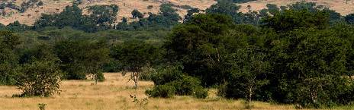

Day 4

Kibale National Park - Queen Elizabeth National Park
Today, you'll have the opportunity to track the famous chimpanzees of Kibale National Park. With 98% genetic similarity to humans, these primates are our closest relatives. They are located in 21 countries throughout Africa but are most easily found Uganda due to their dense populations. In Uganda today there are approximately 5,000 chimpanzees left in the wild. The trekking experience takes place along well-maintained trails, offering a chance to encounter these fascinating creatures in their natural habitat. Kibale is also home to a remarkable variety of other primates, boasting more species than any other East African forest. Alongside chimpanzees, you may encounter red Colobus monkeys, red-tailed guenons, white-nosed monkeys, gray-cheeked mangabeys, blue monkeys, L’Hoest’s monkeys, and black and white colobus monkeys. Afterward, you'll transfer to Queen Elizabeth National Park for a night game drive, with the possibility of an additional evening game drive if time permits.
Main Destination:
Queen Elizabeth National Park
Best Time To VisitJanuary to February and June to July (Dry seasons)
High SeasonJune to September (Peak time for Uganda)
Best WeatherJune to July and January to February (Less rainfall)

Wildlife in Queen Elizabeth NP
ChimpanzeeOccasional


ElephantCommon


LionCommon


BuffaloCommon


HippoAbundant


LeopardOccasional


GiraffeNone


White RhinoNone


Black RhinoNone


CheetahNone


ZebraNone


WildebeestNone


Wild DogNone
Accommodation:
Lake Munyanyange Caves Lodge
- Mid-range lodge located just outside Queen Elizabeth NP







+5Photos

Meals & Drinks:
- All meals included
- Drinking water (Other drinks not included)
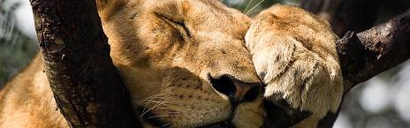

Day 5

Queen Elizabeth National Park
Today, you will drive to the famous Queen Elizabeth National Park and begin your morning game drive. With 200 kilometers of well-maintained game viewing tracks, Queen Elizabeth National Park offers a remarkable safari experience. The park is home to an impressive population of wildlife, including around 5,000 hippos, 2,500 elephants, and over 10,000 buffaloes. You can expect to encounter Africa’s iconic species such as elephants, giraffes, buffaloes, and various antelope species. Predators like lions, leopards, civets, genets, and serval cats roam the grasslands, while black-and-white colobus monkeys are often seen in the trees. Baboons, known for their bold nature, are also commonly sighted. After the morning game drive, you will return to the lodge for lunch before embarking on a boat cruise along the Kazinga Channel.
Main Destination:
Queen Elizabeth National Park
Accommodation:
Lake Munyanyange Caves Lodge
- Mid-range lodge located just outside Queen Elizabeth NP
Meals & Drinks:
- All meals included
- Drinking water (Other drinks not included)
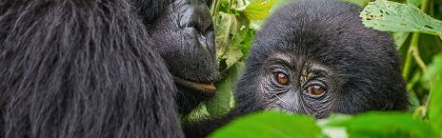

Day 6

Queen Elizabeth National Park - Bwindi Impenetrable National Park
Wake up early and enjoy breakfast before heading out in search of tree-climbing lions. Afterward, you will proceed to Bwindi Impenetrable National Park. Bwindi is a significant habitat for mountain gorillas in Uganda, with an estimated population of 400 (roughly half of the world's total) living here. The park is home to several habituated gorilla groups, allowing for gorilla tracking experiences. Upon arrival, you will check in to your accommodations and have a relaxing afternoon in preparation for the trekking experience scheduled for the following day.
Main Destination:
Bwindi Impenetrable National Park (Gorillas)
Best Time To VisitJune to August and December to February (Gorilla trekking is easiest)
High SeasonJune to September (Gorilla permits are scarce)
Best WeatherJune to July and December to February (Less rainfall)

Wildlife in Bwindi Impenetrable NP

GorillaCommon

ChimpanzeeRare


ElephantRare


White RhinoNone


Black RhinoNone


LionNone


GiraffeNone


LeopardNone


CheetahNone


BuffaloNone


ZebraNone


WildebeestNone


HippoNone
Accommodation:
Rushaga Gorilla Lodge
- Mid-range lodge located just outside Rushaga (Bwindi Impenetrable NP)







+40Photos

Meals & Drinks:
- All meals included
- Drinks not included
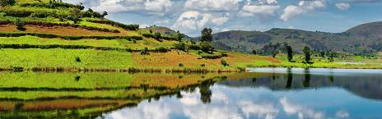

Day 7

Bwindi Impenetrable National Park - Lake Bunyonyi
After an early breakfast and a briefing by a ranger guide, you will enter the gorilla sanctuary for your adventure. The beauty of this rainforest is spectacular! The area features a dramatic, steeply forested landscape that is incredibly dense, crisscrossed by numerous animal trails accessible to tourists. The time taken and the terrain vary with the movements of these great primates. Once you locate a gorilla group, you will be allowed an hour in their presence. The thrill of spending time observing these gentle and endangered giants is an awesome, exciting experience to be savored long after. Return to your lodge for some rest and lunch. Later, you’ll transfer to Lake Bunyonyi. Upon arrival, check into your accommodations, relax, and enjoy your dinner and overnight stay.
Main Destination:
Lake Bunyonyi
Accommodation:
Lake Bunyonyi Eco Resort
- Mid-range resort located at Lake Bunyonyi









Meals & Drinks:
- All meals included
- Drinking water (Other drinks not included)
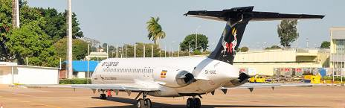

Day 8

Lake Bunyonyi - Entebbe
Eat a relaxing breakfast at your accommodations, enjoying spectacular views of the Bunyonyi hills right in front of you. Afterward, begin your return journey to Entebbe Airport. Expect en route stopovers in Mbarara town for lunch and at the Uganda equator in Kayabwe for some memorable photos and souvenir shopping. You’ll arrive at the airport in the afternoon or the evening. We hope to see you (or any referral) on your next visit and thank you for choosing Lulu Safaris Uganda.
Main Destination:
Entebbe (City)
Accommodation:
No accommodation (End of tour)
Meals & Drinks:
- Breakfast & lunch (Dinner not included)
- Drinking water (Other drinks not included)

End of tour
- Additional accommodation can be arranged for an extra cost.
- You'll be dropped off at the airport.

Important to Know
- This tour is not available to solo travelers.
- Rates are per person and exclude the international flight from/to your home country.
- This tour accepts children who are 16 years and older.

Rates Per Person
Start dates | Solo1 room | 2+ people Sharing rooms
Jan 1, 2025 - Dec 31, 2025 | n/a* | $3,245
Jan 1, 2026 - Dec 31, 2026 | n/a* | $3,245
Jan 1, 2027 - Dec 31, 2027 | n/a* | $3,245

Included
- Park fees(For non-residents)
- Gorilla permits(One per person, non-resident)
- Chimp permits(One per person, non-resident)
- All activities(Unless labeled as optional)
- All accommodation(Unless listed as upgrade)
- A professional driver/guide
- All transportation(Unless labeled as optional)
- All Taxes/VAT
- Roundtrip airport transfer
- Meals(As specified in the day-by-day section)
- Drinks(As specified in the day-by-day section)

Excluded
- International flights(From/to home)
- Additional accommodation before and at the end of the tour
- Tips(Tipping guideline US$10.00 pp per day)
- Personal items(Souvenirs, travel insurance, visa fees, etc.)
- Government imposed increase of taxes and/or park fees

